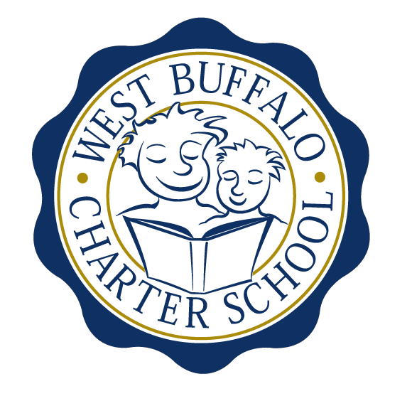
West Buffalo Charter School

Board of Trustees Meeting
October 26th, 2015
2:30 PM
D’Youville College
Bauer Family Academic Center, Room 105

Minutes

Board Members:
Present: Arup Sen, James Deuschle, Michelle Stevens, Joanne Haefner, Richard Baer, Lee Pearce

Excused: Joseph Cozzo, James Sampson
Absent: Lucy Candelario
Quorum Present: Yes
Also Present: Andrea Todoro, Liz Sterns

Call to Order
Dr. Sen called the Meeting to order at 2:43 PM. Quorum present.

Proof of Public Notice of Meeting
Media and public announcement was sent on Monday, October 19th, 2015 to print, radio, and TV outlets announcing this open meeting. A posting was also sent to Erie County Hall, Buffalo City Hall and Buffalo City Court. In addition, it was publicly displayed at 50 East North Street and posted on the WBCS website. The Board of Trustees was duly notified of this meeting well within the timeline of our bylaws.

Review of the September 28th, 2015 Meeting Minutes
Minutes of the September 28th, 2015 Board of Trustees meeting were presented for approval.

Upon motion duly made by Ms. Haefner and seconded by Mrs. Stevens, the minutes of the September 28th, 2015 board meeting were approved as presented. All in favor. Non-opposed.

- Discussion regarding the expansion plan. Mr. Deuschle and Mrs. Sterns to fine-tune the financials relative to expansion with the aim for application submission to SED on November 2nd, 2015.
- Further discussion on expansion and capital cost for expansion.
- Upon motion duly made by Mr. Baer and seconded by Mrs. Stevens, the request for material revision of the application was approved as presented. All in favor. Non-opposed.

Financial Report

- Mrs. Sterns presented the financial report for the period ending September 30th, 2015 (a copy which is attached hereto and made a part hereof).

Upon motion duly made by Mrs. Stevens and seconded by Mr. Baer, the September 30th, 2015 financial statements were approved as presented. All in favor. Non-opposed.

- The financial audit is complete and will be filed with the State on November 1st, 2015.
- An E-vote will be taken to approve the MOU between WBCS and the group through VISTA who will use WBCS as the host site for individuals to learn how to prepare their own taxes. Two nights, one in January, 2016 and one mid-February will be scheduled.
- The decorative banners are ready to be installed along the Lafayette side of the building.
- Discussion regarding vandalism and a suggestion made that we might need security on site for the hours of 4:00 PM to midnight. Mrs. Stevens suggested that Dr. Sen or Mr. Deuschle place a call to “D” district Captain regarding the recent incidents of vandalism as well as the lack of response to calls from WBCS in general.

School Leader Report

- Discussion regarding the Transgender and Gender Non-Conforming policies.

Upon motion duly made by Ms. Haefner and seconded by Mrs. Stevens, the WBCS Transgender and Gender Non-Conforming Students Policy Acknowledgement was approved as presented. All in favor. Non-opposed.

- A request will be made to Alcott HR to begin to conduct exit interviews with any WBCS staff member that resigns from WBCS.
- Discussion regarding the language change in the WBCS Employee Manual regarding:
- Shift from two weeks to 30 day notice
- Paid Time Off
An E-vote to be taken as soon as possible.
- A suggestion was made regarding Alcott HR to provide a staff survey to be completed anonymously by the employees that would help to provide feedback of those currently on staff at WBCS. Dr. Sen will provide the survey that is used at D’Youville that can be used as reference.

Upon motion duly made by Ms. Haefner and seconded by Mr. Baer, the board approved as presented the MOU between the Community Academic Center (CAC), and WBCS. All in favor. Non-opposed.
- The CAC program will take place Monday through Thursday on-site at WBCS from 3:30 PM to 5:30 PM. Two teachers from WBCS will serve as the leads for this program that will be run by Buffalo State College staff. Insurance will be provided by Buffalo State as well as background checks for all associated with the program.

Adjournment

There being no further business to discuss, a motion to dismiss was made by Mrs. Stevens and seconded by Mr. Deuschle. The meeting was adjourned 3:50 PM.

Respectfully submitted,
Leslie Bunis Ohl

The next board meeting is scheduled for Monday, November 23rd, 2015 at 2:30 PM at D’Youville College (Bauer Family Academic Center-BFAC, Room 105).

Mark your calendar: Dr. Sen will host a holiday party on Saturday, December 12th at 6:00 PM. Details to follow.

